# Overview

In this lab you will establish the prerequisites for Active Directory installation.

# Objectives

Be able to establish and configure the prerequisites for installing Active Directory.

# Prerequisites

Guided Practice - **Computer Setup** is complete.

# Scenario

Prior to installing Active Directory on your CIS256-DC1, CIS256-DC3, and CIS256-DC2 virtual machines you need to verify that you meet all the requirements.

# Tasks

## Verifying/Establish prerequisites for AD on the CIS256-DC1 vM

1. **Start** the **CIS256-DC1** virtual machine.
2. Verify the computer has the following:
   1. A static IP address.
   2. Operating system partition is NTFS.
3. Install the Active Directory Domain services role using PowerShell as follows:
   1. **Open PowerShell** console with **Administrative** rights.
   2. Type the following command:

Install-WindowsFeature -Name AD-Domain-Services -IncludeManagementTools

1. Verify the installation of AD Domain services by using the following command:

Get-WindowsFeature AD-Domain-Services

1. You can also use the following command to verify that the AD administrative tools were installed:

Get-WindowsFeature *AD*

## Verify/Establish prerequisites for AD on CIS256-DC2 and CIS256-DC3 vMs

**Repeat** the procedure above for the **CIS256-DC2** and **CIS256-DC3** VMs.

## Submission Requirements

1. **On** your **VMHost** system**, create** a **folder** in the root of your **C:\** named **Scripts**. Log into Canvas and access this course. **Download** the **grading** **script** from the assignment page to the **C:\Scripts** folder.
2. Check your lab by running the following command:

Invoke-Pester -Path C:\Scripts\GP03-Establishing_Prerequisites_ for_AD_Installation.test.ps1

**Note**: You will see a security warning when running the script. Enter **R** to run the script.

If you want to see more detail, add **-Output Detailed** to the command. This may assist you with troubleshooting

Invoke-Pester -Path C:\Scripts\GP03-Establishing_Prerequisites_ for_AD_Installation.test.ps1 -Output Detailed

1. You should not see any red in the output. Red in the PowerShell way of telling you that an error condition exists. Most of the time, the output will tell you what is wrong. If it is not obvious, contact your teacher and ask for assistance. You will be learning PowerShell during this term. **Correct** any **errors** you may have and run the script until all the output has no red. You should see the output like the images below.

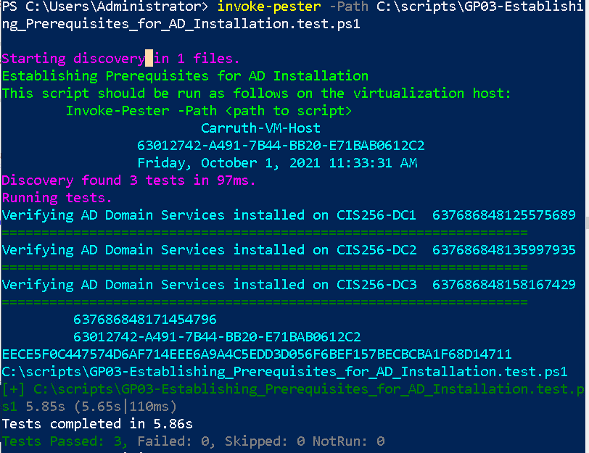

1. Capture a snippet that shows the PowerShell Command and all its output. If you must use more than one snippet to capture the output, you must have at least **one line of overlap** in the snippets. The text in the snippets **must be legible** when pasted into the Word document. Paste the snippet(s) into a **new** **Word** **document.**
2. **Upload** the **document** in the submission area for the assignment.